IoT Power Plug
The IoT power plug with the ESP32 chip ensures protection of the devices connected to its extensions. The extensions included supports two 110VAC and 5VDC based devices each.
The ESP32 chip works with both WiFi and Bluetooth Low Energy (BLE) and is more stable and advanced than any other IoT microcontrollers. Here in this product, the ESP32 WROOM 32 chip suits best considering all our requirements. The overall product is equipped with surge protector (triple MOV configuration) and a FUSE to ensure superior safety. Similarly, when the ESP turns off the power supply to the extension plugs, the relay configuration completely isolates the devices connected to the extension from the main power line. The power plug also includes a buzzer module controlled by the ESP chip and a 15 Watt DC power supply to power the overall control system and the 5VDC power extension.

Block Diagram
Signal flow
Power flow
To extension
110V AC
Buzzer Module
ESP32
Relay Module
Surge Protection

SMPS 15W

3.3V Regulator

Schematic diagram
The PCB is designed in two layers: the bottom layer and the top layer. The significance of this design method is to isolate the AC circuits from the delicate DC circuits. Besides that, stacking the PCB one above another serves for compact design of the product. The schematic of each layer is shown below with the description of the functional units it includes.
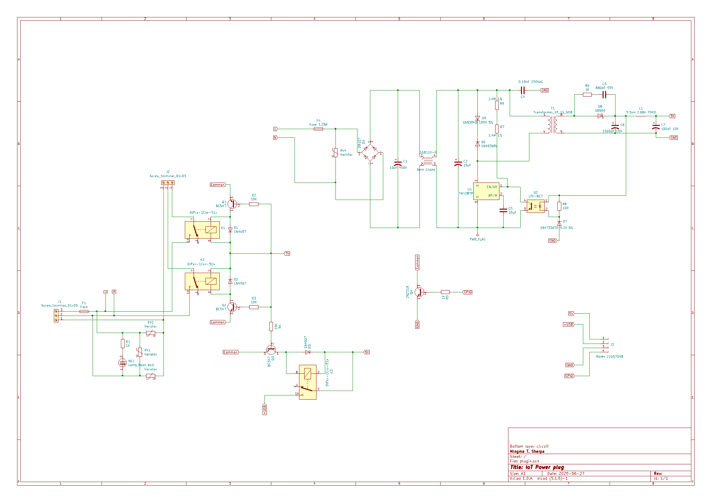
FIG: Schematic of the bottom layer PCB
The above schematic includes the following functional units:
- Triple surge protection with FUSE
- Relay configuration for switching the power to extensions
- 15W SMPS DC power supply
- Connectors for power and ESP32.

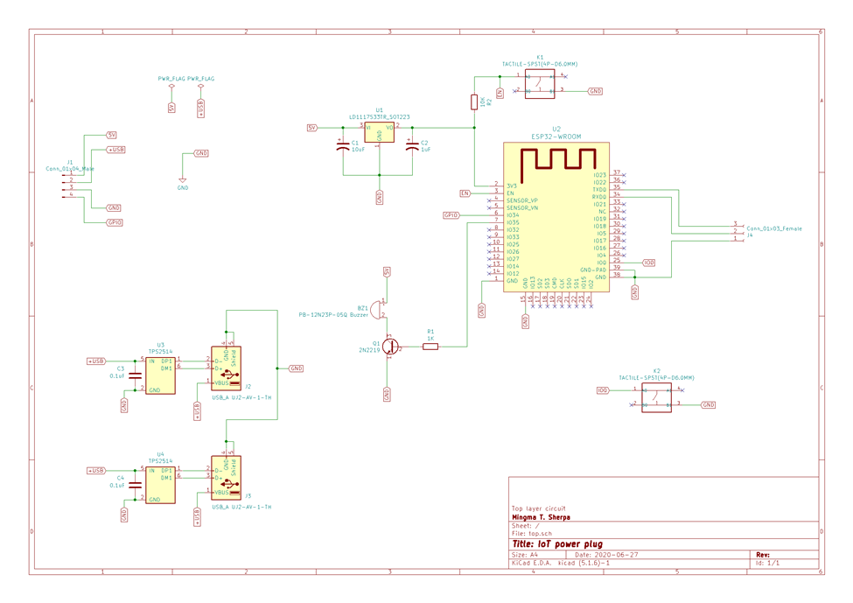
FIG: Schematic of the top layer PCB

The above schematic includes the following functional units:
- ESP32
- 3.3V DC power regulator for ESP32
- Two 5VDC USB outlets
- Buzzer module
- Connectors for power and ESP32

